Exercise 1 PL/SQL – Sanskar Kumawat
Part 0 – Created a Database Table
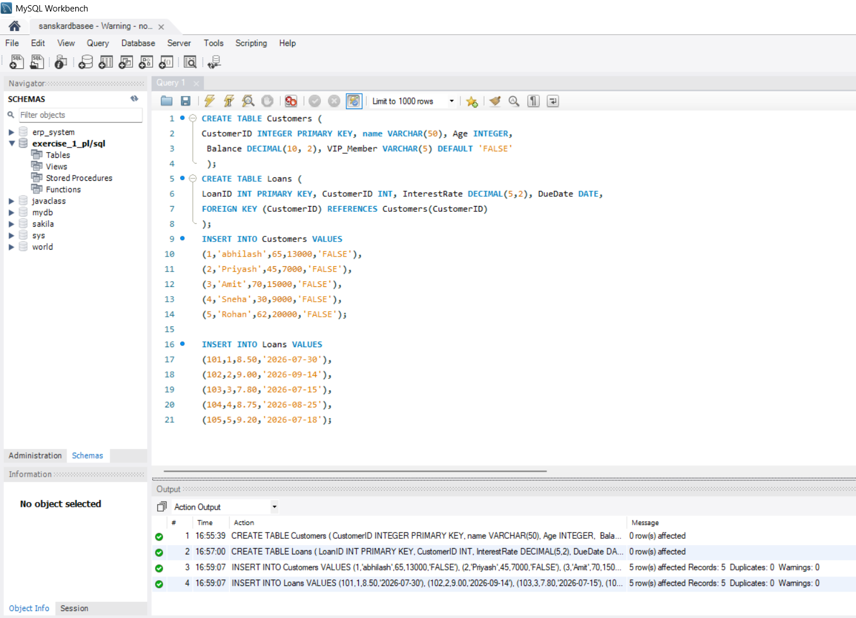
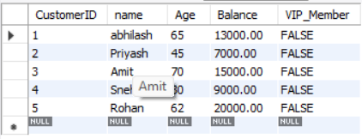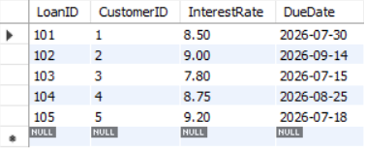
Part 1 – scenario 1 - The bank wants to apply a discount to loan interest rates for customers above 60 years old.(1% reduction)
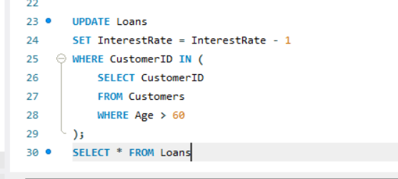
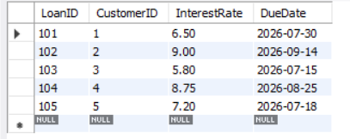output
Part 2 - scenario 2 : A customer can be promoted to VIP status based on their balance.
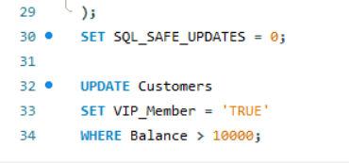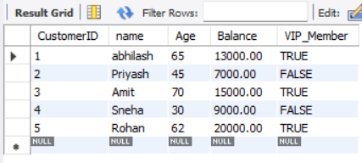
Part 3 - scenario 3: The bank wants to send reminders to customers whose loans are due within the next 30 days.
